Food to Door

**Students names:**

Reem Almualem 2190000429

Narjis Al-Jummaia 2190000716

Sarah Alghamdi 2200000185

**Instructors**

Dr. Thowiba Awad TA. Maha Alghamdi

Academic year 1442-2021

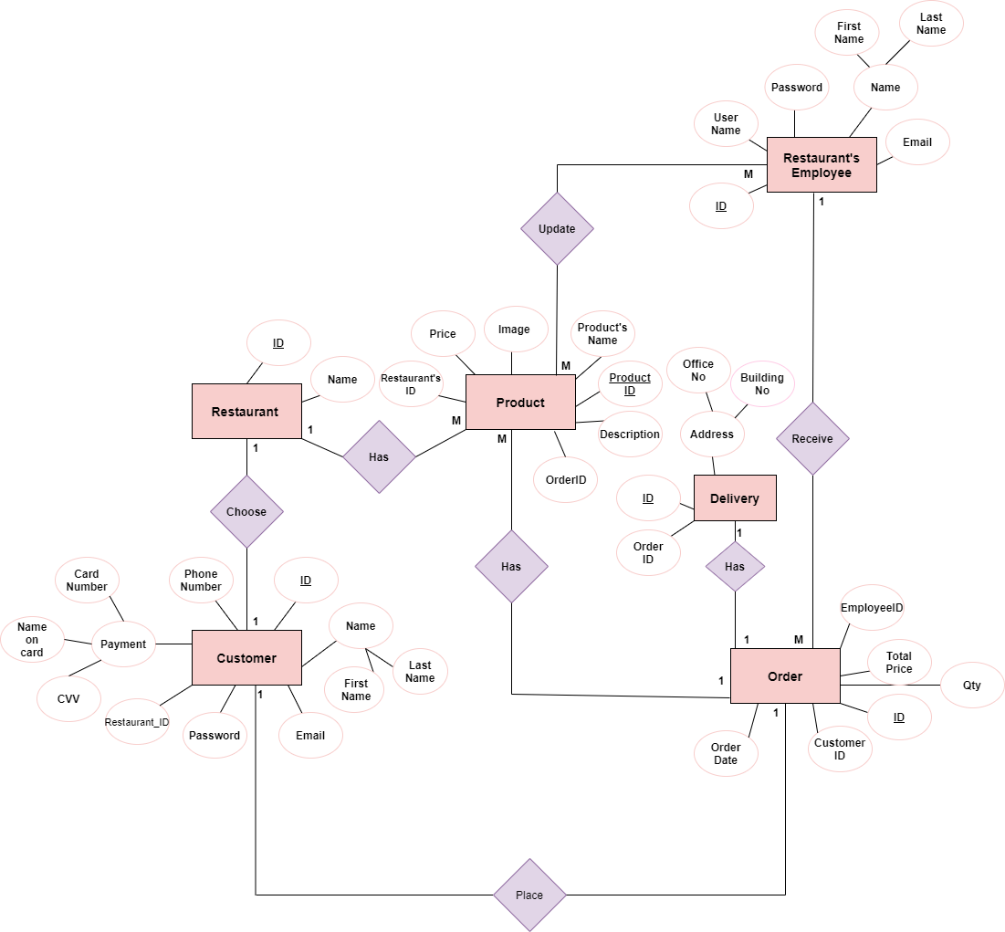Food to Door ERD

Food to Door Mapping tables

